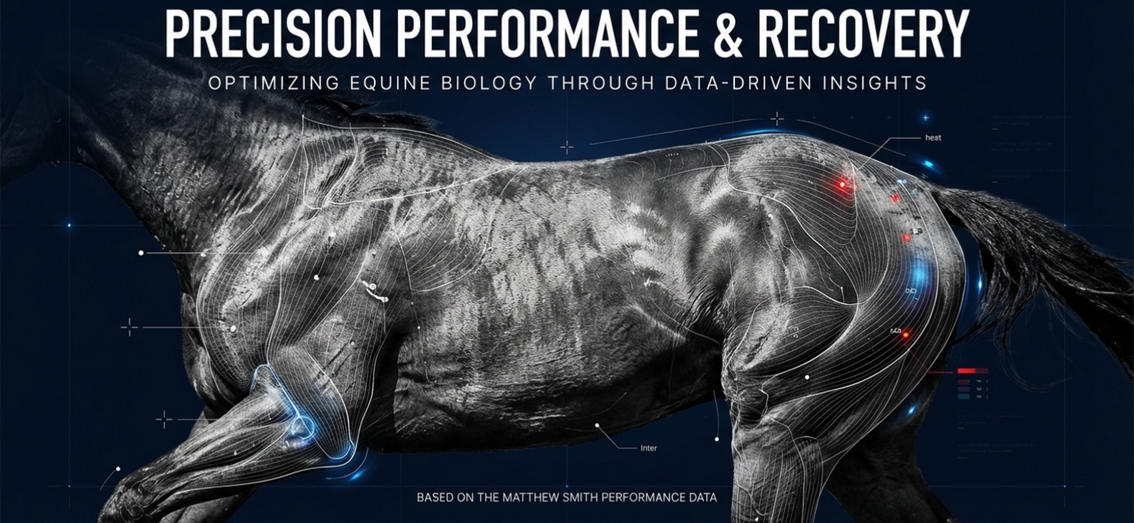
Based on Real Data Analysis
A system enhancing Horse racing performance and recovery with the integration of biometric data to enhance equine performance and ensure optimal recovery.
A precise monitoring of hydration levels and the strategic tuning of Elite Equine diet.
Ultimately, the goal is to combine scientific data with human intuition and knowledge to ensure horses are physically prepared for elite competition.
Precision Performance offers a specialized tracking system creating an individualised program for elite performance thoroughbreds. A unique urinalysis software shows a remarkable insight in monitoring critical health markers like hydration, electrolytes, and pH levels. The analysis provides a carbohydrate-to-salt ratios, aiming to establish a "healing zone" for recovery. By analysing the turbidity and conductivity of urine, the team seeks to reduce wasted metabolic energy and refine individualized feeding schedules.
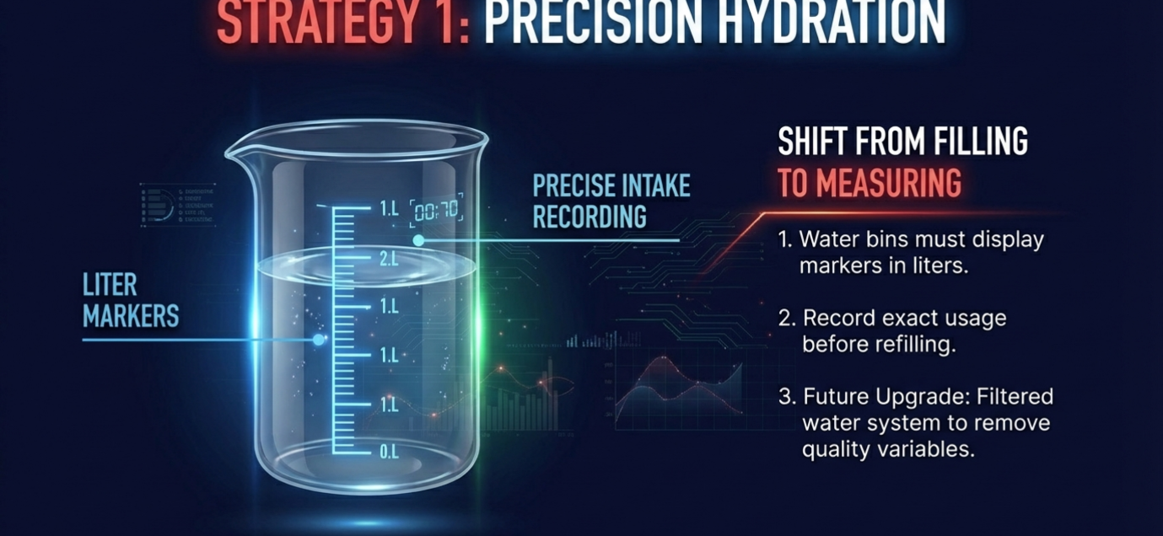
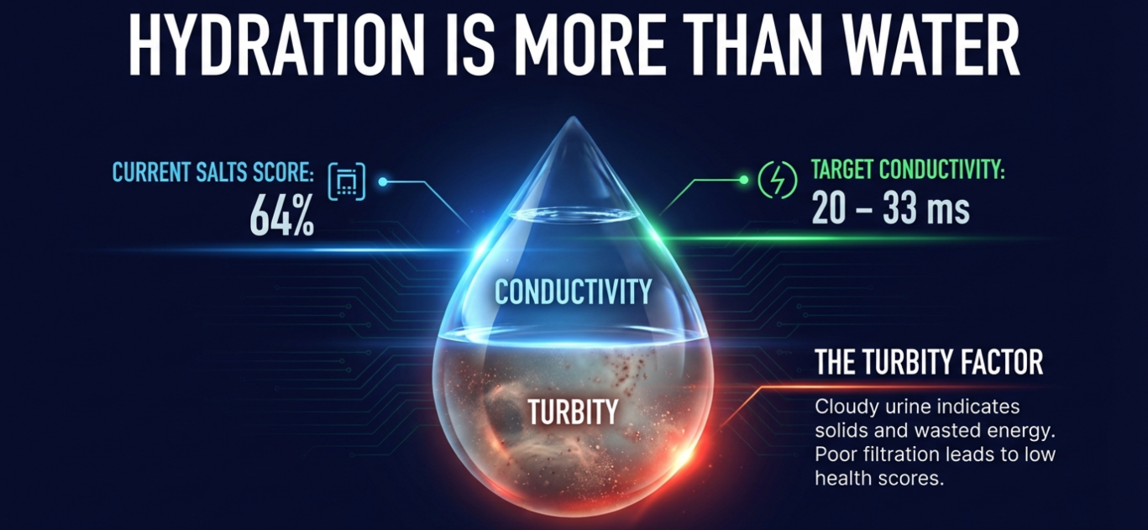

The Role of Hydration in Recovery
Hydration is about more than just water intake; it is a balance of salts, conductivity, and dissolved solids.
- Monitoring Methods: While physical indicators like the skin "pinch test" or membrane refill time can provide quick estimates of dehydration (e.g., a "tented" skin pinch indicating 6-8% dehydration), blood testing is considered the "gold standard" for accuracy. Professionals use a formula involving sodium, glucose, and urea levels to determine a hydration score.
- The Healing Zone: An aim for a health and hydration score of 90% or better before engaging in "hard hit outs". If scores are low, training should be backed off to prevent overstressing the system, as the body cannot recover quickly when dehydrated.
- Urine Conductivity: High salt levels or high conductivity in urine (e.g., a reading of 50C vs. a target of 25C) often indicate dehydration and "wasted energy". When conductivity is too high, the body is essentially throwing out waste, including undigested proteins, urea and minerals rather than utilizing them. This puts unnecessary pressure on the athlete's internal chemistry including inflammation and vascular and heart health stress.
Dietary Tuning for Performance and Recovery
Strategic Dietary tuning involves adjusting the volume, timing, and type of nutrients to match the athlete's specific energy needs and recovery state, kept in check with analytical data.
- Electrolyte Balance and pH: All soluble minerals are valuable in optimum health, Potassium for example is critical for heart function and must be carefully managed, especially in hot or humid conditions where it is lost through sweat.
- Energy Source Matching: Recovery and performance needs are different based on the type of exertion:
  - Sprinters (Anaerobic): Generally, require higher carbohydrate, starch, and sugar levels.
  - Stayers/Endurance (Aerobic): Benefit from increased fat intake, which produces less lactic acid than carbohydrates during long-distance work.
- Reducing Digestive Stress: To aid recovery, it is often beneficial to reduce the volume of feed while maintaining nutrient density. For example, using whey protein allows for high protein intake and essential branched-chain amino acids (BCAAs) while cutting back on total food volume, thereby reducing the energy the body must spend on digestion. Phil mentioned, in this case hydration is critical to benefit from the high quality, low volume food source to maximise output.
- Carbohydrate Sensitivity: Elevated carbohydrate levels in urine can indicate a lack of oxygen to the brain, leading to "moody" or "panicky" behaviour and/or extreme lethargy. Tuning the diet to avoid "sugar hits" ensures the athlete remains stable and minimum recovery “down time” in preparation for next training session or event.
Consistency as a Strategy
The most successful recovery programs are strict patterns based on the numbers. Repetition of mealtimes, precise quantities, and hydration to the body's chemistry. By establishing these baselines and monitoring outliers, you can identify exactly when an “athlete” has moved out of their "zone" and apply precise corrections—such as adjusting salt types or hydration timing—to bring them back to peak recovery status.
Blood (serum) testing is the "gold standard" for determining a horse’s immediate hydration status. Blood results are accurate because they allow a trainer to put a specific numerical figure on the level of dehydration rather than relying solely on physical observations like a skin pinch test. Serum testing is "immediate" and provides an instant understanding of the horse's current state, but blood is not always suitable for horses and stable hands who cannot act immediately to correct the numbers.
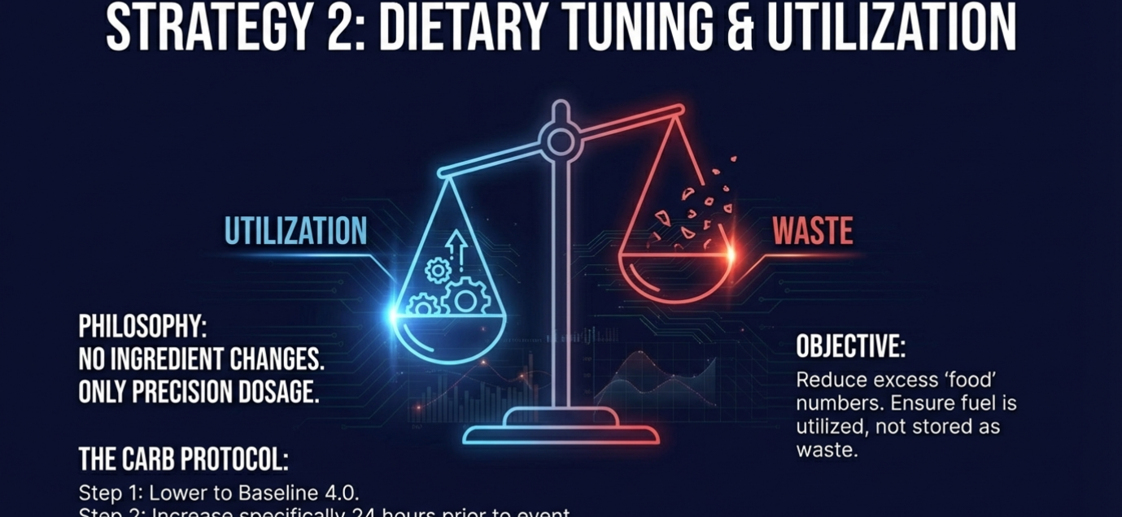
Urine testing benefits:
- Long-term Trends: Regular urine analysis is an excellent way to determine a horse’s needs over a longer period.
- Dietary Tuning: Urine testing is more effective for defining feeding schedules and identifying exactly what nutrients or electrolytes the horse might be lacking or wasting.
- Diagnostic Value: While blood gives the "the moment" status, the urine analysis helps determine what the horse "actually needs" to maintain its balance on a day-to-day basis and in real time. A non-invasive way to manage a horse's long-term nutritional and performance health.
Urine testing provides a valuable trend-based perspective that shows what a horse "actually needs".
Final collective insights and agreement on the following key areas:
- Individualization and Baselines: Agreement on creating individualized programs rather than applying a "broad brush" approach to the entire stable. It’s noted that once a "perfect" baseline is established for a horse—often seen in champion horses whose blood results are "absolutely perfect"—trainers can use subsequent tests to identify when a horse has drifted outside its peak performance zone and work to get them back to that state.
- Sensitivity to Change: Horses are extremely sensitive, so trainers must be "very, very careful" when making any dietary or supplemental changes. The extra information provided by these tests are a tool to ensure changes are beneficial rather than disruptive to the horse's chemistry. The numbers will show changes.
- Specific Dietary Requirements: Nutritional needs vary significantly by the type of exertion; for instance, sprinters (anaerobic) often require higher sugar and starch, whereas stayers (aerobic) possible benefit from increased fat to reduce lactic acid production. (atm the focus is on Anaerobic.)
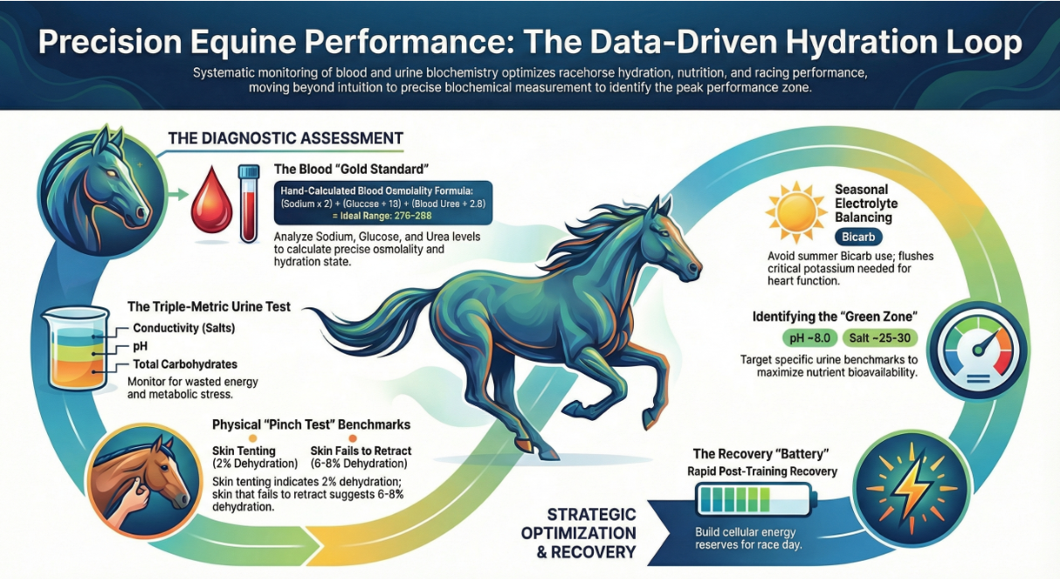
- Immediate Tactical Advice: Ultimately the combination of blood and urine testing is a way to replicate the quality of high-performing horses and keep them consistently in their "zone". The more numbers or data the better the results, extended racing campaigns and improved rest out in the paddock.



